


SECONDARY PACKAGING MACHINE

OPERATION & SERVICE MANUAL

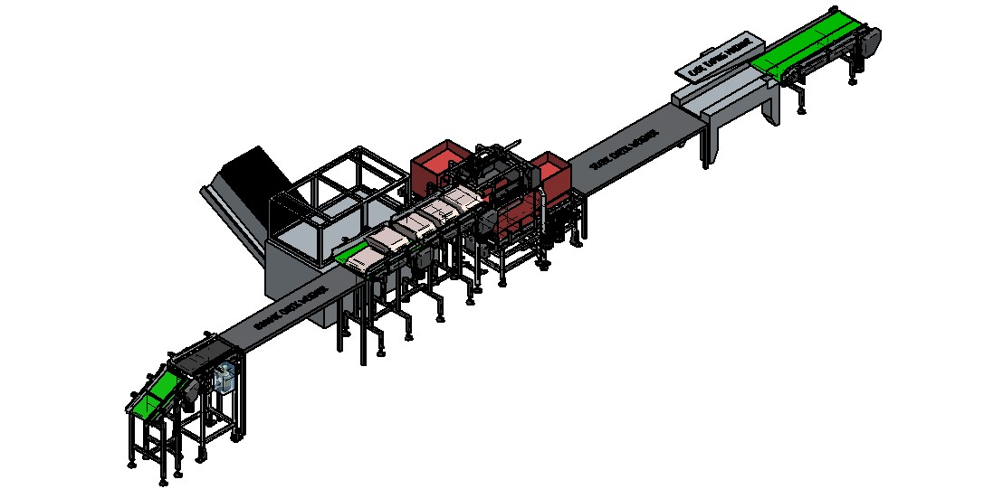

PREFACE

Thank you for choosing SECONDARY PACKAGING MACHINE
Our company always insists on the concept of integrity marketing, long term strategic partnership and strict quality controlling and fast after-sales service. We would like to train our people as a team who are of fast reaction, transposition consideration & efficient working. Along with the strength of our technician's team, the promotion and infiltration of the professional quality inspection system & the appearance of outstanding service men, now our company has established the long-term strategic cooperative partnership with the customers found it difficult to determine and solve some of technical issues. Such service can achieve the purpose to enhance the end-satisfaction, promote and sale our SECONDARY PACKAGING MACHINE. So we prepare this special Operations service & Spares Manual.

This manual classify and analyses on the phenomenon of different issues with logical guidance ideas of the flow chart, simulation of the actual operation and the aid of steps explanations, which is designed to help you to strengthen your service, men’s ability on study, professional communication and systematic ideas to solve the problem in a very short time.

This manual is used for installation instruction, caution items and basic program settings.

To ensure that SECONDARY PACKAGING MACHINE will work with safety, high-efficiency for a long period, please read instruction manual and customer support carefully for additional assistance.

CONTENT

CHAPTER 1: INTRODUCTION 04-05

CHAPTER 2: SAFETY 06-09
- Safety Instruction
- Basic Caution Items
- Caution Items for Maintenance
- Caution Items for Machine Operation

CHAPTER 3: INSTALATION PROCEDURE 10-11

CHAPTER 4: ASSEMBLY 12-29

CHAPTER 5: FAULTS & REMEDIES 30

CHAPTER 6: INSTALLATION PROCEDURE 31

CHAPTER 1 INTRODUCTION

INTRODUCTION

SECONDARY PACKAGING MACHNE is used to pack various products into empty carton boxes. This includes automation in various operations such as Product Conveyor, Carton Popup, Proper distribution of material in pouch using vibratory conveyor, Product pushing into carton, Sequential placing of pouch in carton & formation of matrix, carton discharge conveyor. These systems in the machine, work on mechanical and electrical principles.
Special Features
- Minimum maintenance.
- Epoxy MS Powder Coated structure.
- Contact parts SS_304.

Specification | Control | Electrical switch
Specification | Mode of operation | Electrical & Pneumatic
Specification | Conveying Material | Carton and Pouch
Specification | Power Requirement | 420V, 50 HZ Three Phase
Specification | Air requirement | 5-6 CFM AT 5 TO 6 BAR

CHAPTER 2: SAFETY

SAFETY INSTRUCTIONS

In this operating manual as well as on machine you will see a variety of symbols & their meanings are given as follows. Please read the following items carefully to ensure that the equipment can be operated safely & correctly.

The standardization of the equipment operation is the product of every technician’s efforts. Please read & learn the signs with commitments.

The danger marks means the danger may cause extensive harmful consequence might even result in casualty accident. In order to prevent this accident we must strictly follow the operating rules.
Danger
The warning mark means it may cause danger, even result in casualty accident. In order to prevent this accident we must operate according to the instruction.

Warning

The caution mark is referred to potential danger, mainly served as precaution warning, in order to prevent injuries and keep machine work with long term stability; it tells what should be noted and the correct way to operate.
Caution

The important mark means how to prevent the equipment problem in order to extend the life expectancy of the machine and use the machine to best.

Important

BASIC CAUTION ITEMS

Please make sure all electric fixing is in good condition and the machine cover is fully sealed before turning on.
Danger
Operator should wear suitable uniform, do not wear loose uniform, tie, decoration or long hair. To avoid damage, it is not allowed to touch the roller or bearing in Caution running machine.

Caution Items for Maintenance:
Please cut off the power supply and lock the switch box before maintenance. Only professional should be allowed to operate. Any components revise or addition for electric system may affect regular functions and cause safety problems.
Danger
You can change the spare parts only 5 minutes later after cutting off the power supply.

Warning

Avoid using water for cleaning machine or machine parts. And also use appropriate spanners and tool for tightening of machine assembly.
Caution

Caution Items for Machine Operation:

To protect the safety of operator and equipment and enhance the anti-disturb ability, each of the equipments should be connected with ground wire separately.

Important
It is forbidden to open the machine cover to operate before cutting off the power supply to avoid electric shock; it is not allowed to dismantle spare Parts, clean, oil
and maintain when running either.
Caution

Only trained instructed personnel should operate the machine or system. And it is to be operated in accordance with the appropriate specifications and with due
Important regard to the operating instructions.

Do not commence cleaning, maintenance or repair work until the main switch has been switched off.
Danger
Do not lean against the running machine and ensure that adequate clearance is maintained around the machine and do not touch any electrical parts or wire when
Caution machine is on.

Before removing plug-in units for the purpose of exchanging and also before undoing any electrical connections always turn off the main switches as the Caution electronic components may otherwise get destroyed.

Caution Items for Installation Environment Condition

The installation place must be rigid and without shaking, the working environments should be without wind.
Important

CHAPTER 3: INSTALLATION PROCEDURE

Process of Installation

- Keep the machine at the required location on a leveled ground. Foundation is not required. Adjustable foots are provided for the leveling of the machine. Make sure that legs are adjusted as shown in following figure.
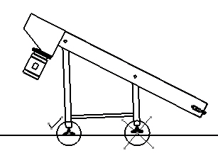
- Make earthing to machine.

- Make all electrical connections as per the enclosed diagram.

- Give 420 V AC 50 HZ, Three phase supply.

- The machine is now ready to start.

Periodic maintenance:(Frequency: weekly)

- Greasing of roller chains.

- Check the Belt & Chain Tension.

- Clean all machine parts.

- Check for Air and Vacuum leakages (if any).

Instructions for Maintenance

Daily Check up Procedure

- Check alignment of belt and roller.
- Check Belt & Chain tensioning.
- Check assembly fasteners are properly tight or not.

CHAPTER 4: ASSEMBLY

4. ASSEMBLY

SECONDARY PACKAGING MACHINE

ISOMETRIC VIEW
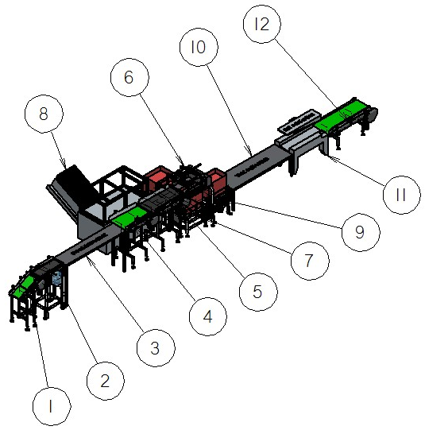

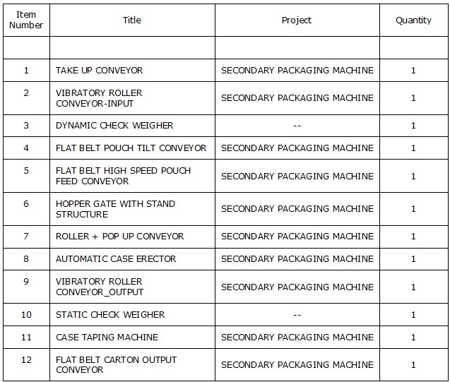

- TAKE UP CONVEYOR

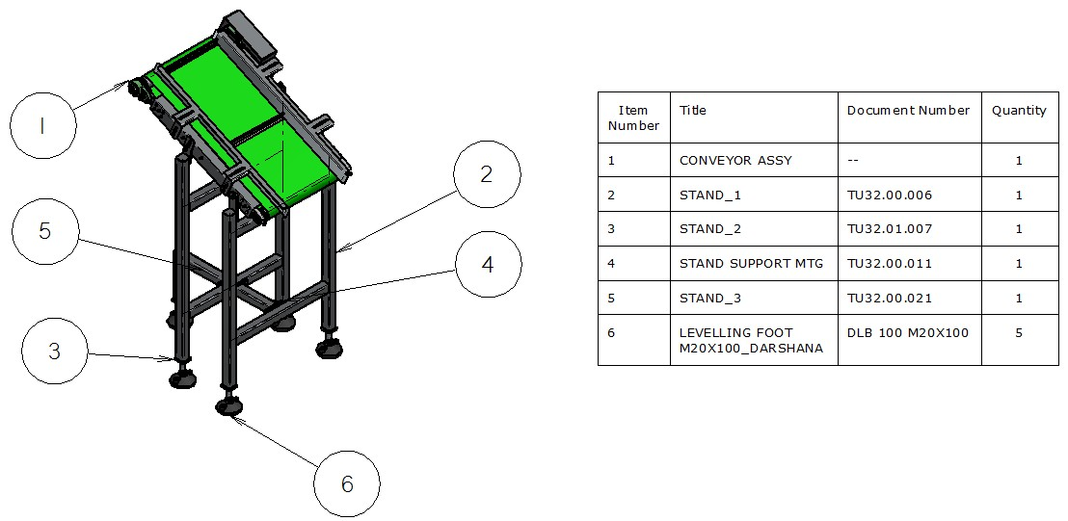
Take up Conveyor transfer the product (5 Kg Pouch) from Primary Packaging Machine to next level Vibratory Roller Conveyor-Input.

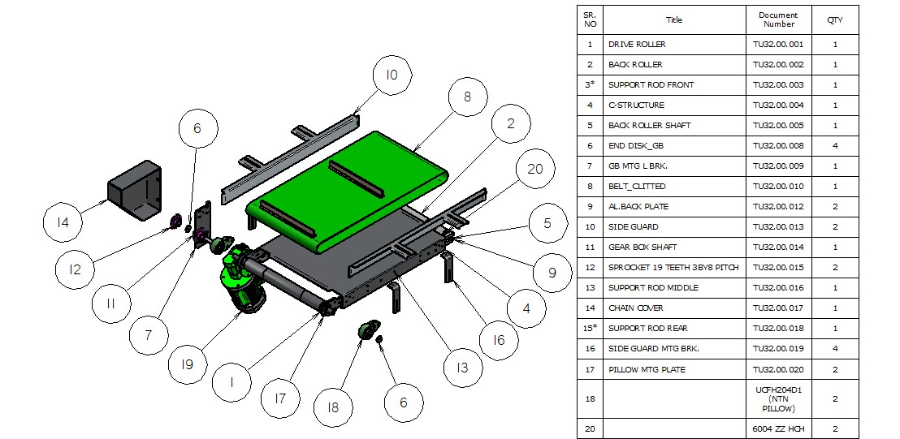
- VIBRATORY ROLLER CONVEYOR-INPUT

On Vibratory Roller Conveyor-Input, received product vibrates as well as transferred to Dynamic check Weigher. For ease of transfer flat belt is provided with Tensioning arrangement.

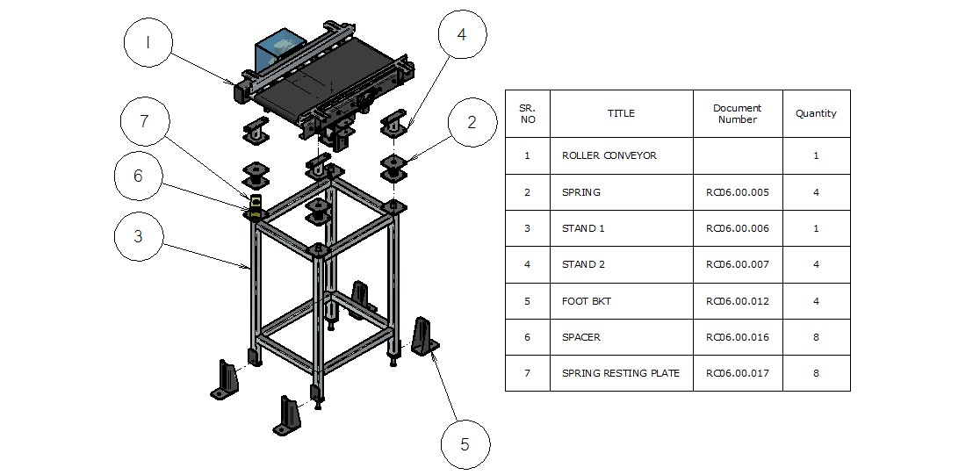
.

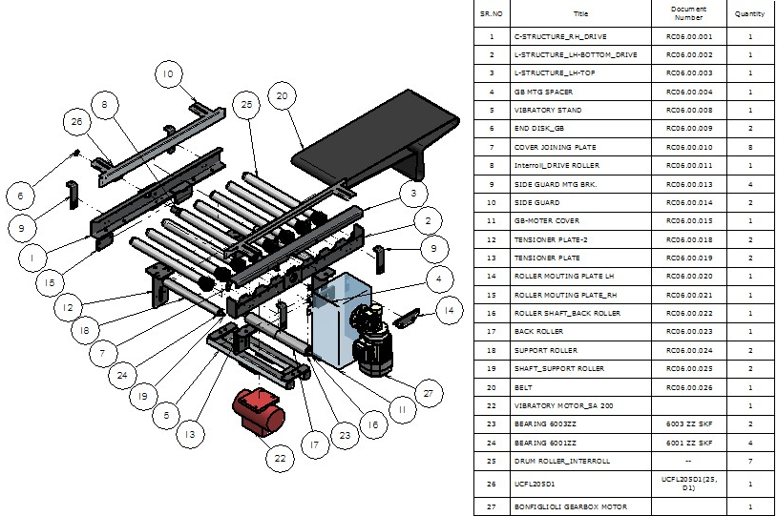
- FLAT BELT POUCH TILT CONVEYOR

On Flat belt Pouch tilt conveyor, incoming pouches tilt by 90 degree. Pouches are coming from Primary Packaging Machine in width direction. On tilt conveyor they are turn by 90 degree, at output side of this conveyor pouch will feed by length direction.
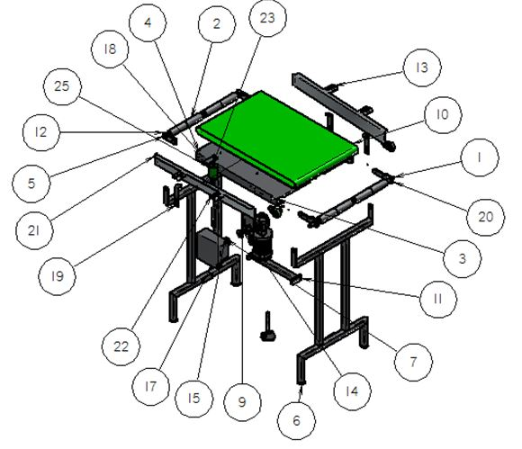

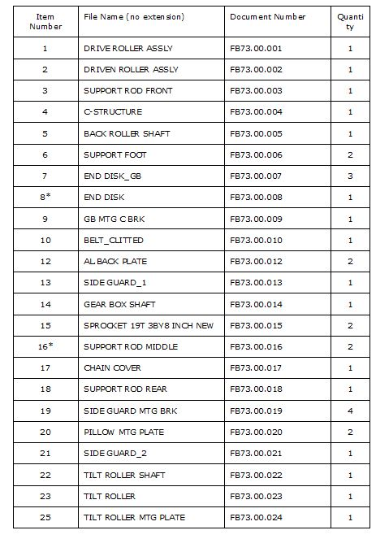

- FLAT BELT HIGH SPEED POUCH FEED CONVEYOR

On flat belt high speed pouch feed conveyor, pouches travel with high speed. Because of the high speed pouches easily slide into the hopper gate assembly.

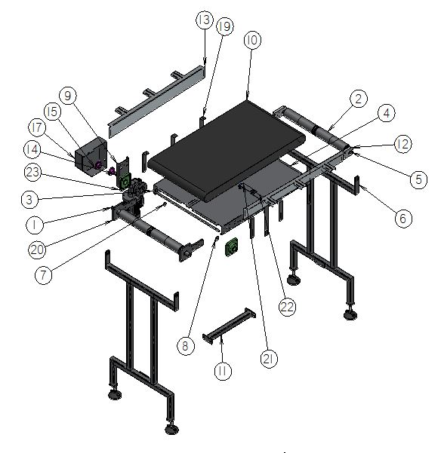
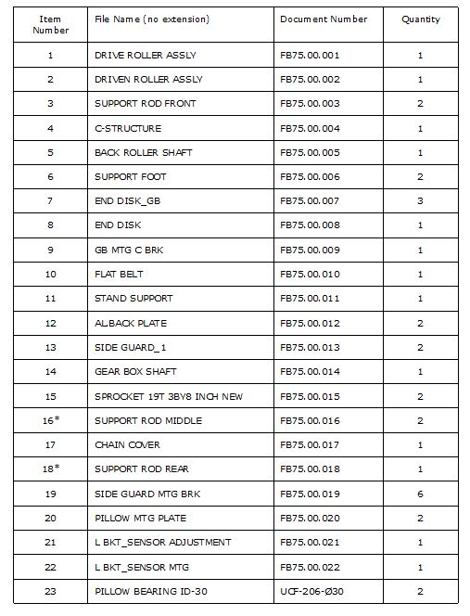

- ROLLER + POPUP CONVEYOR

In Roller + popup conveyor unit, It transfer formed Carton from Automatic Carton Erector to below to Hopper gate Assembly. It uses two roller conveyor and one flat belt conveyor.
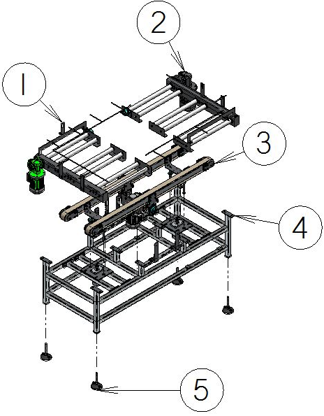

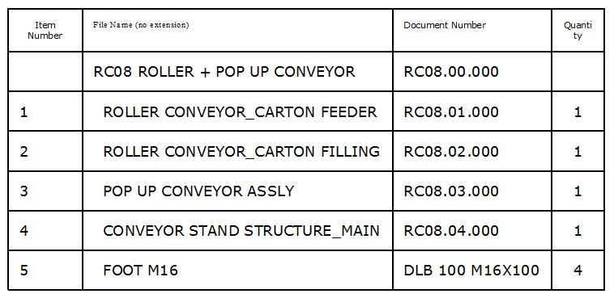

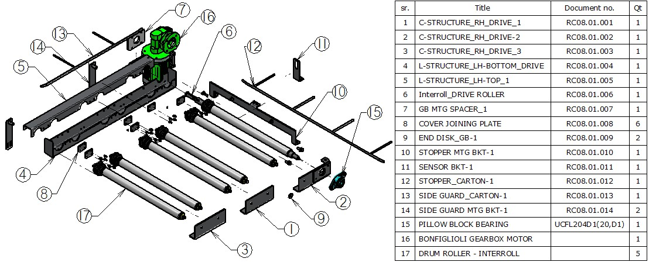
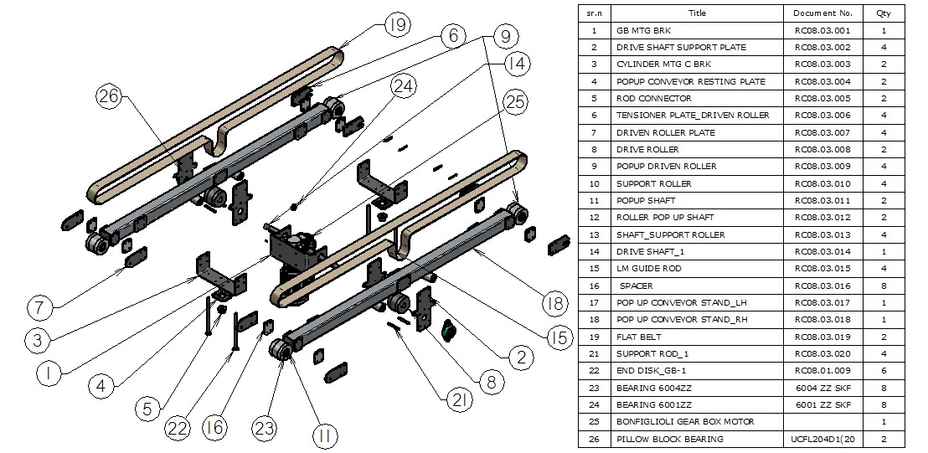
Roller conveyor- Carton feeder is connected to output of Automatic Carton Erecter. It receives well formed carton. Once carton received in position sensor senses its presence and starts the Popup Flat belt conveyor which is lifted by Pneumatic Cylinder.

When popup conveyor lifts up to certain height it get start and it convey empty carton towards Roller conveyor- carton filling.

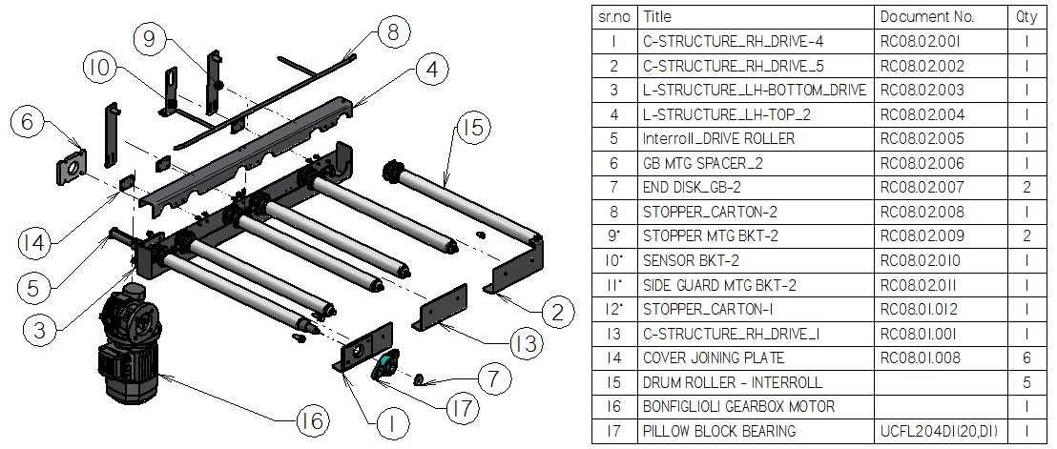

After reaching Carton at Roller Conveyor- Carton Filling just below the Hopper Gate Assembly, Pop Conveyor Stop rotating and lifts down. Finally carton rests on Roller Conveyor hopper Gate Assembly start to fill the carton. In the end carton completely filled Counter sensor send the signal to Roller conveyor- Carton filling and it get start. Now filled carton passes to Vibratory Roller Conveyor.

- HOPPER GATE ASSEMBLY

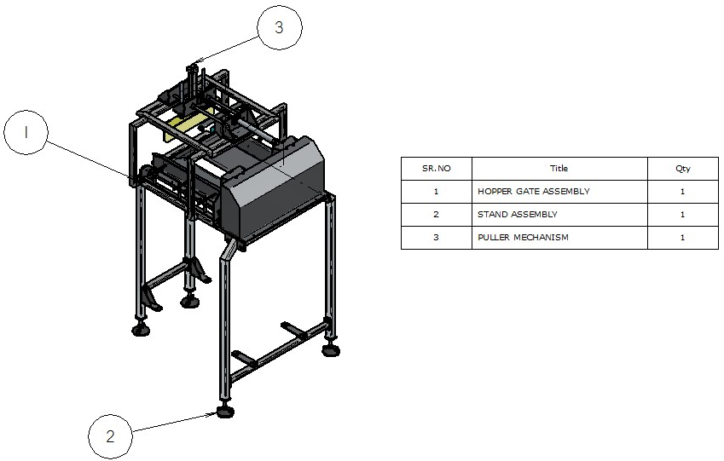
In Hopper Gate assembly, pouches are drop into the carton which is exactly below Hopper Gate. On Hopper Gate Assembly Puller mechanism is also provided to pull pouch into the Hopper Gate assembly. Puller Mechanism Works on pneumatic Cylinder.
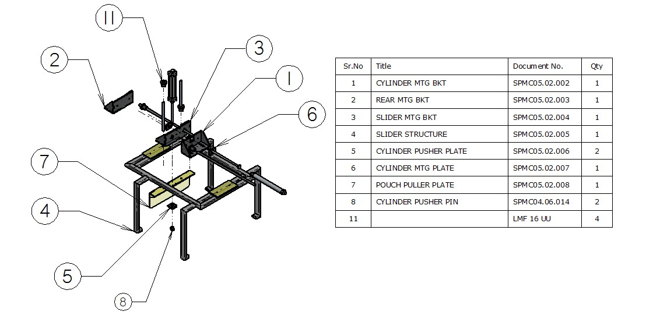

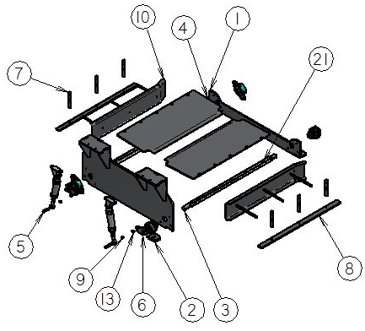

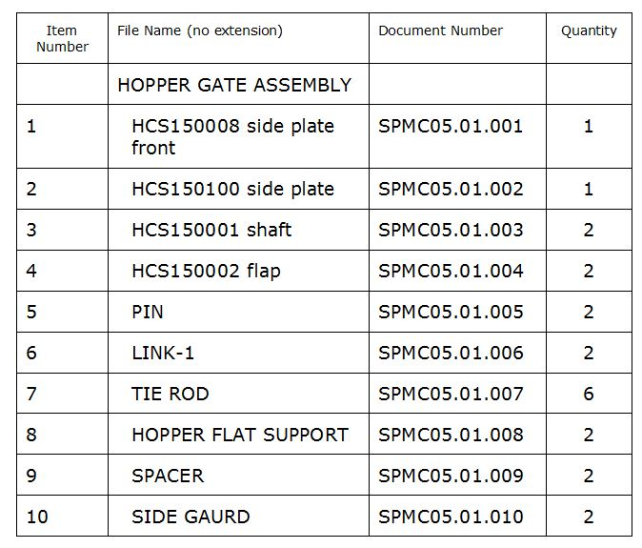

- VIBRATORY ROLLER CONVEYOR-OUTPUT

On vibratory roller conveyor - output filled carton with pouches vibrates to settle down pouches. This will helps to Case taping Machine to close upper flap.
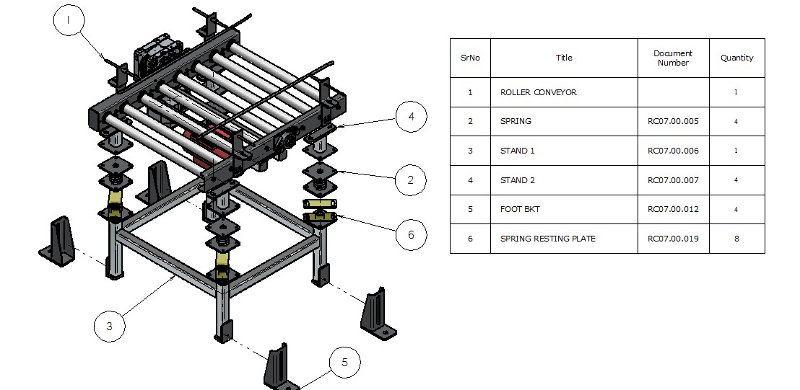

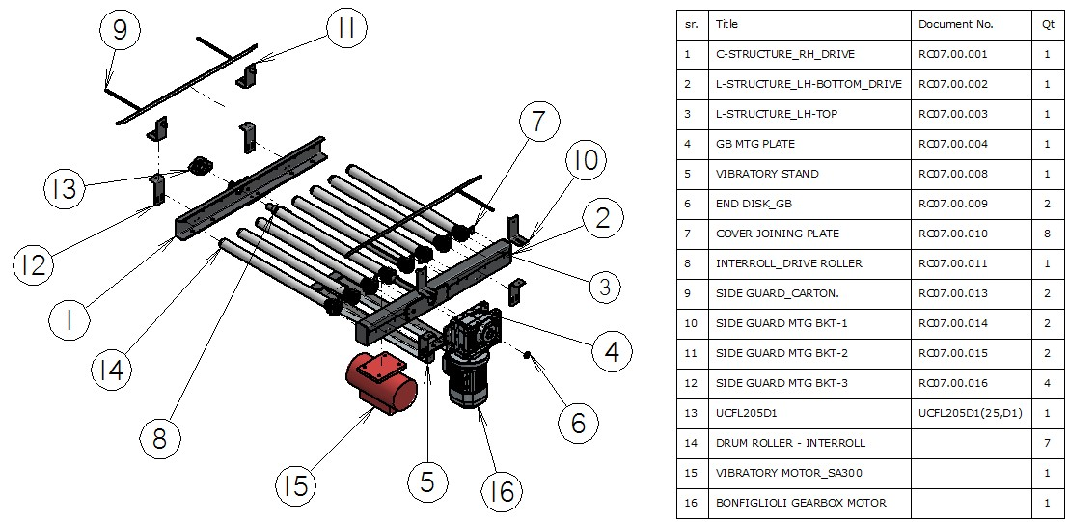

- FLAT BELT CARTON PRINTING (OUTPUT) CONVEYOR

On Flat belt Carton Printing Conveyor, product information will print on carton. After that these carton are ready to dispatch or store in Ware House.

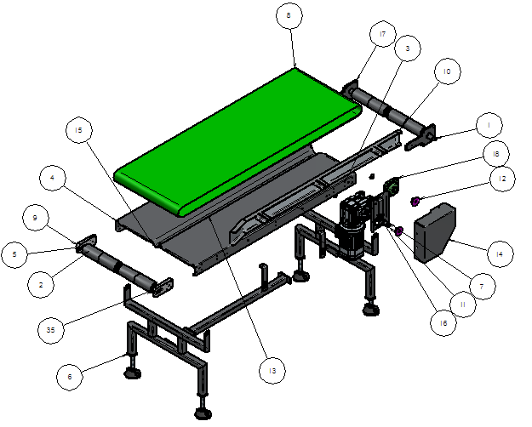

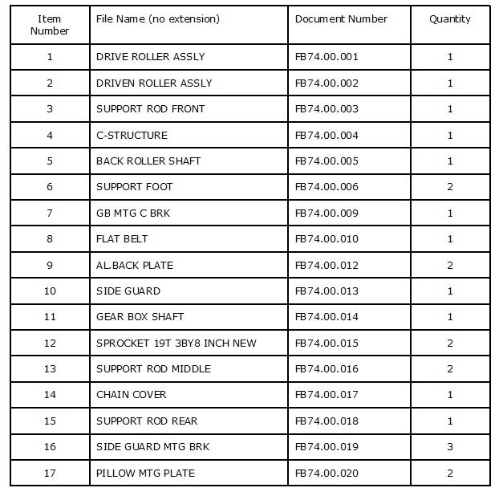

CRITICAL PART LIST

Sr. no | Item Name | Item No | Total Qty.
1 | DEEP GROOVE BALL BEARING 6001 SKF 2Z | 6001 SKF 2Z | 12 NOS.
2 | DEEP GROOVE BALL BEARING 6002 SKF 2Z | 6002 SKF 2Z | 2 NOS
3. | DEEP GROOVE BALL BEARING 6003 SKF 2Z | 6003 SKF 2Z | 2 NOS.
4. | DEEP GROOVE BALL BEARING 6004 SKF 2Z | 6004 SKF 2Z | 14 NOS.
5 | PILLOW BLOCK UCFL 204-DIA20 | UCFL-204-DIA20 | 8 NOS
6 | PILLOW BLOCK UCFL 205-DIA25 | UCFL-205-DIA25 | 2 NOS
7 | 3 POINT BEARING UCFH204D1-dia20 | UCFH-204- DIA 20 | 4 NOS
8 | PILLOW BLOCK UCF 206-DIA30 | UCF-206-DIA30 | 4 NOS
9 | IGUS BUSHING | GFM1214-08 | 2 NOS
10 | CKG LINEAR SLIDE UNIT LMF 16UU | LMF 16UU | 4 NOS.
11 | CKG LINEAR SLIDE UNIT LMF 12UU | LMF 12UU | 4 NOS.
12 | SMC 5/2 SINGLE SOLENOIDE VALVE 24 VDC, 1/8 | SMC-SY5120-5LZ-01 | 2 NOS.
13 | SMC 5/2 SINGLE SOLENOIDE VALVE 24 VDC, 1/4 | SMC-SY7120-5LZ-02 | 1 NOS.
14 | SMC 5/2 SINGLE SOLENOIDE VALVE 24 VDC, 1/8 | SMC-SY5320-5LZ-01 | 1 NOS.
15 | PILOT OPERETED CHECK VALVE | SMC-ASP330F-01-08S | 4 NOS.
17 | PILOT OPERETED CHECK VALVE | SMC-ASP430F-02-08S | 4 NOS.
18 | SILENCER | SMC-AN10-01 | 6 NOS.
19 | SILENCER | SMC-AN20-02 | 2 NOS.

CHAPTER 5: FAULTS AND REMEDIES

- Belt / Chain Alignment is not proper.

Check sprocket / pulley alignment

- Pneumatic cylinder not functioning.

Check reed switch operation condition

CHAPTER 6: INSTALLATION

Process of Installation

1. Keep the machine at the required location on a leveled ground. Foundation is not required. Adjustable foots are provided for the leveling of the machine as shown following figure.

2. Make earthling to machine.

3. Make all electrical connections as per the electrical diagram.

4. Give 420 V AC 50 HZ, Three phases A.C. Supply.

5. Follow the procedure explained in flowchart.

